Course outcomes-2

**Program 1:**

Aim:-

Implementation of BitString Operations using C

Source code:-

//bit string operations

#include<stdio.h>

void main(){

int uni[50],i,u,n,m,a[50],b[50],k,j,o;

int ab[50],bb[50];

printf("Enter size of universal set\n");

scanf("%d",&u);

printf("Enter universal set of %d elements",u);

for(i=0;i<u;i++)

scanf("%d",&uni[i]);

printf("Enter size of set A\n");

scanf("%d",&n);

printf("ENter %d elements",n);

for(i=0;i<n;i++)

scanf("%d",&a[i]);

printf("Enter size of set B\n");

scanf("%d",&m);

printf("ENter %d elements",m);

for(i=0;i<m;i++)

scanf("%d",&b[i]);

for(i=0;i<u;i++){//loop to convert sets inti bit string

ab[i]=0;bb[i]=0;

for(j=0;j<n;j++)

if(uni[i]==a[j])

ab[i]=1;

for(k=0;k<m;k++)

if(uni[i]==b[k])

bb[i]=1;

}

do{

printf("\n\nEnter operation to perform\n");

printf("1.Display bit string\n2.Union\n3.Intersection\n4.Set difftrence(A-B)\n5.exit");

scanf("%d",&o);

switch(o){

case 1:printf("\nBit string\nA:");

    for(i=0;i<u;i++)

    printf("%d",ab[i]);

    printf("\nB:");

    for(i=0;i<u;i++)

    printf("%d",bb[i]);break;

case 2:printf("\nunion:\t");

    for(i=0;i<u;i++)

    printf("%d",ab[i]|bb[i]);break;

case 3:printf("\nIntersection:\t");

    for(i=0;i<u;i++)

    printf("%d",ab[i]&bb[i]);break;

case 4:printf("\nset diffrence:\t");

    for(i=0;i<u;i++)

    printf("%d",ab[i]&(!bb[i]));break;

case 5:printf("\n\n******************************Thank U************************\n\n\n");break;

default:printf("Enter a valid i/p\n");

}

}while(o!=5);

}

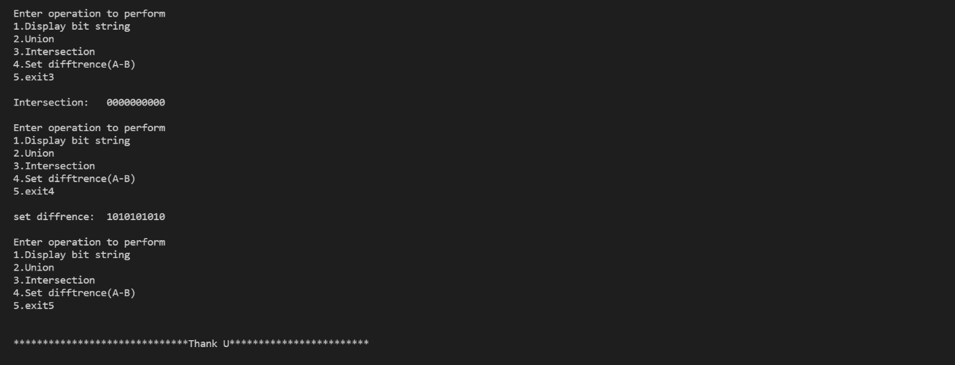Output:-

